**Commodore VIC-20: Hyper Expander Rev. 1**

**Module Description**

Table of Content

Introduction 1

Configuration 2

Note 2

EPROM Chip selects 2

RAM Chip Selects 2

*JP5* 2

*JP4* 2

BYTES FREE 2

Memory Bank Select (EPROM) 3

EPROMs 4

Using parallel EEPROMs 5

Dimensions 6

Assembly and BOM 6

2 EPROM Build 6

Full RAM Build 6

No RAM, just EPROM 6

Other Options 6

Revision History 7

Rev. 0 7

Rev. 1 7

# Introduction

The Hyper Expander is a cartridge for the Commodore VIC-20, which provides up to 16kB EPROM and up to 37kB RAM. It is a super-set of the original Commodore VIC-1211A Super Expander, which provides only 3k of RAM.

The Hyper Expander can hold up to two 27C512 EPROMs, the 8k memory bank of both EPROMs (A13...A15) can be selected for both EPROMs. The same selection applies to both of them. Each EPROM (IC1 and IC2) can be jumpered to two chip selects. That is or for IC1 and or for IC2.

The RAM consists of two 32kB 62256 type static RAMs. The memory is divided into four banks each. Two 74LS148 decode the active chip selects to one of each memory bank. The used chip selects can be configured with JP4 and JP5.

# Configuration

## Note

The chip selects of the EPROM and the RAM can be concurrent. The same chip select must not be used for RAM and EPROM at the same time.

## EPROM Chip selects

|  |  |  |  |
| --- | --- | --- | --- |
| *EPROM* | *Jumper* | *Chip Select* | *VIC-20 Address* |
| *IC1* | *JP1* |  | *$4000 - $5FFF* |
|  | *$A000 - $BFFF* |
| *IC2* | *JP2* |  | *$2000 - $3FFF* |
|  | *$6000 - $7FFF* |

Table 1: Configurable Chip Selects

In case an EPROM should be deactivated, it is only required to pull JP1 and/or JP2. The chip select then is HIGH (inactive) due to new pull-up resistors.

## RAM Chip Selects

### *JP5*

JP5 activates the chip select signals, that are then decoded and address the respective RAM bank of IC3.

| **Pin** | **Chip Select** | **Addresses** |
| --- | --- | --- |
| 1-2 |  | $2000 - $3FFF |
| 3-4 |  | $4000 - $5FFF |
| 5-6 |  | $6000 - $7FFF |
| 7-8 |  | $0400 - $0FFF |

Table 2: Jumper settings JP5

### *JP4*

JP4 activates the chip select signals, that are then decoded and address the respective RAM bank of IC5.

| **Pin** | **Chip Select** | **Addresses** |
| --- | --- | --- |
| 1-2 |  | $A000 - $BFFF |
| 3-4 |  | $9800 - $9BFF |
| 5-6 |  | $9C00 - $9FFF |
| 7-8 |  | Unused (experimental) |

Table 3: Jumper settings JP5

# BYTES FREE

Be aware, that not all RAM configurations will lead to a more BASIC memory (the BYTES FREE) on switch on. The BASIC memory has to be coherent.

The memory map (screen RAM, BASIC RAM) of the VIC-20 depends on the memory expansion. It will be different for internal RAM and 3k Expansion.

| **RAM Configuration** | **BYTES FREE** |
| --- | --- |
|  | 6655 |
|  | 11775 |
| and | 11775 |
| and | 19967 |
| , and | 28159 |
| , , *, and* | 28159 |
| , , | 6655 |

Table 4: Reported BASIC RAM

RAM that is not visible as BASIC RAM can of course still be accessed. In case an is selected, the lowest 3k are not visible as BASIC RAM. In case a memory gap is configured (like and *are configured, but* is missing, the BASIC RAM consists of the internal RAM and the 3k RAM expansion.

The **Super Expander** Software (in ROM) requires 136 bytes of RAM. In case this software is activated (it is associated to) the BASIC memory will be reduced by this number of bytes.

# Memory Bank Select (EPROM)

There are two different types of addresses mentioned in this document:

* VIC-20 Address
* EPROM Offset Address

Both types must not be confused! The EPROM Offset Address is the address of the selected memory bank within (the program buffer of the EPROM). This is, where you load the different binary files to the EPROM buffer. One of those memory banks is selected with the Jumper JP3. This appears in/is mapped to the VIC-20 memory at the address determined by the chip select (see Table 1).

|  |  |  |  |  |  |  |
| --- | --- | --- | --- | --- | --- | --- |
| JP3 | | | Address Bits | | | EPROM Address  (Offset) |
| **A15** | **A14** | **A35** | **A15** | **A14** | **A13** |
| SET | SET | SET | L | L | L | 0x0000 – 0x1FFF |
| SET | SET | OPEN | L | L | H | 0x2000 – 0x3FFF |
| SET | OPEN | SET | L | H | L | 0x4000 – 0x5FFF |
| SET | OPEN | OPEN | L | H | H | 0x6000 – 0x7FFF |
| OPEN | SET | SET | H | L | L | 0x8000 – 0x9FFF |
| OPEN | SET | OPEN | H | L | H | 0xA000 – 0xBFFF |
| OPEN | OPEN | SET | H | H | L | 0xC000 – 0xDFFF |
| OPEN | OPEN | OPEN | H | H | H | 0xE000 – 0xFFFF |

Table 5: 8k cartridges memory banks

# EPROMs

Four different types/sizes of EPROMs can be used with the Super Expander II, not all settings make sense with them. Their pin out is shown in Table 6.

The effect of the settings and the recommended configurations are shown in Table 7.

|  |  |  |  |  |  |  |  |  |  |  |  |
| --- | --- | --- | --- | --- | --- | --- | --- | --- | --- | --- | --- |
| **27C64** | | | | | | | | | | | |
|  | **27C128** | | | | | | | | | |  |
|  | **27C256** | | | | | | | |  |
|  | **27C512** | | | | | |  |
|  | **SOCKET** | | | |  |
| Vpp | Vpp | Vpp | A15 | 1 | A15 | VCC | 28 | VCC | VCC | VCC | VCC |
| A12 | A12 | A12 | A12 | 2 | A12 | A14 | 27 | A14 | A14 | /PGM | /PGM |
| A7 | A7 | A7 | A7 | 3 | A7 | A13 | 26 | A13 | A13 | A13 | n.c. |
| A6 | A6 | A6 | A6 | 4 | A6 | A8 | 25 | A8 | A8 | A8 | A8 |
| A5 | A5 | A5 | A5 | 5 | A5 | A9 | 24 | A9 | A9 | A9 | A9 |
| A4 | A4 | A4 | A4 | 6 | A4 | A11 | 23 | A11 | A11 | A11 | A11 |
| A3 | A3 | A3 | A3 | 7 | A3 | /OE | 22 | /G/Vpp | /G | /G | /G |
| A2 | A2 | A2 | A2 | 8 | A2 | A10 | 21 | A10 | A10 | A10 | A10 |
| A1 | A1 | A1 | A1 | 9 | A1 | GND | 20 | /E | /E | /E | /E |
| A0 | A0 | A0 | A0 | 10 | A0 | D7 | 19 | D7 | D7 | D7 | D7 |
| D0 | D0 | D0 | D0 | 11 | D0 | D6 | 18 | D6 | D6 | D6 | D6 |
| D1 | D1 | D1 | D1 | 12 | D1 | D5 | 17 | D5 | D5 | D5 | D5 |
| D2 | D2 | D2 | D2 | 13 | D2 | D4 | 16 | D4 | D4 | D4 | D4 |
| GND | GND | GND | GND | 14 | GND | D3 | 15 | D3 | D3 | D3 | D3 |

Table 6: EPROM pin compatibility

|  |  |  |  |  |
| --- | --- | --- | --- | --- |
| EPROM | Size | A15 | A14 | A13 |
| 27C512 | 64kx8 | yes | yes | yes |
| 27C256 | 32kx8 | HIGH | yes | yes |
| 27C128 | 16kx8 | HIGH | HIGH | yes |
| 27C64 | 8kx8 | HIGH | HIGH | HIGH |

Table 7: Settings per EPROM type

In case Vpp is located at a dedicated pin (pin 1), A15 has no effect anymore. A HIGH level is recommended (switch is off). The /PGM Pin should be set HIGH. The n.c. (not connected) pin should be HIGH (with pull-up resistor) or open.

# Using parallel EEPROMs

There are ***parallel*** EPROMs, which fit into the EPROM sockets. They do not require erasing with a UV eraser, like EPROMs, but the price is higher.

Since they can be written, which is controlled by the signal, but the Super Expander II cartridge is lacking of this functionality, this signal has to be HIGH (inactive). The 28C256 has the A14 signal connected to Pin 1, which is A15 of the EEPROM socket. This is no problem, but it has to be kept in mind, that the jumper for A15 has effect on the bank select A14 of the EPROM.

|  |  |  |  |  |  |  |  |
| --- | --- | --- | --- | --- | --- | --- | --- |
| **28C64** | | | | | | | |
|  | **28C256** | | | | | |  |
|  | SOCKET | | | |  |
| n.c. | 💣A14 | 1 | A15 | VCC | 28 | VCC | VCC |
| A12 | A12 | 2 | A12 | A14 | 27 | /WE | /WE |
| A7 | A7 | 3 | A7 | A13 | 26 | A13 | n.c |
| A6 | A6 | 4 | A6 | A8 | 25 | A8 | A8 |
| A5 | A5 | 5 | A5 | A9 | 24 | A9 | A9 |
| A4 | A4 | 6 | A4 | A11 | 23 | A11 | A11 |
| A3 | A3 | 7 | A3 | /OE | 22 | /G/Vpp | /OE |
| A2 | A2 | 8 | A2 | A10 | 21 | A10 | A10 |
| A1 | A1 | 9 | A1 | GND | 20 | /E | /CE |
| A0 | A0 | 10 | A0 | D7 | 19 | D7 | D7 |
| D0 | D0 | 11 | D0 | D6 | 18 | D6 | D6 |
| D1 | D1 | 12 | D1 | D5 | 17 | D5 | D5 |
| D2 | D2 | 13 | D2 | D4 | 16 | D4 | D4 |
| GND | GND | 14 | GND | D3 | 15 | D3 | D3 |

Table 8: EEPROM pin compatibility

|  |  |  |  |  |
| --- | --- | --- | --- | --- |
| EEPROM | Size | A15 | A14 | A13 |
| 28C256 | 32kx8 | =A14 | OPEN | yes |
| 28C64 | 8kx8 | OPEN | OPEN | OPEN |

Table 9: Settings per EEPROM type

# Dimensions

The dimensions of the Hyper Expander are identical to those of the original Super Expander PCB.

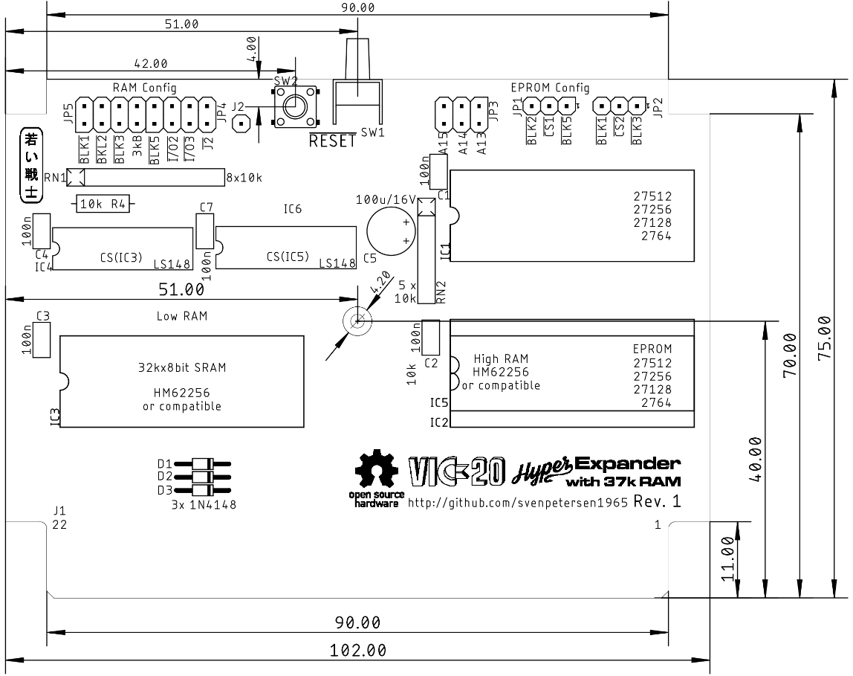

Figure 1: Dimensions of the Super Expander II

The PCB fits the original Super Expander cartridge case, another VIC-20 cartridge case from Commodore or the [tfw8bit.com](http://www.tfw8bit.com/) cartridge case.

The VIC-20 cartridge cases are high enough to fits the Super Expander II PCB even with the ICs on sockets and vertical jumpers. This has been verified for the Super Expander case and the tfw8bit case. The tfw8bit case and the “other Commodore VIC-20” cases require two T-shaped board supports in the middle of the lower shell to be removed.

# Assembly and BOM

The High RAM (IC5) cannot be installed together with the 2nd EPROM (IC2).

## 2 EPROM Build

Do not place: JP4, IC5 and IC6, C7

## Full RAM Build

Do not place: JP2, IC2

## No RAM, just EPROM

Do not place: IC3, C3, IC4, C4, IC5, IC6, C6, RN1, D1-3, R4, JP5, JP4

## Other Options

**SW2** is a vertical RESET switch, while **SW1** is the horizontal option. It is only required to place one.

**JP4** and **JP5** are in the same grid. If bother are required (for full RAM), one 8x2 pin header can be installed.

# Revision History

## Rev. 0

* Prototype: Fully functional.

## Rev. 1

* Second optional RAM (IC5, “High RAM”) to provide the maximum possible RAM
* All jumpers moved to the front edge, so they can be accessed while the cartridge is installed
* Optional vertical RESET switch
* Resistor networks for many pull ups reduce the required space
* Pull ups for the EPROM chip selects